You’re So Much More Than Beautiful
December 3, 2017
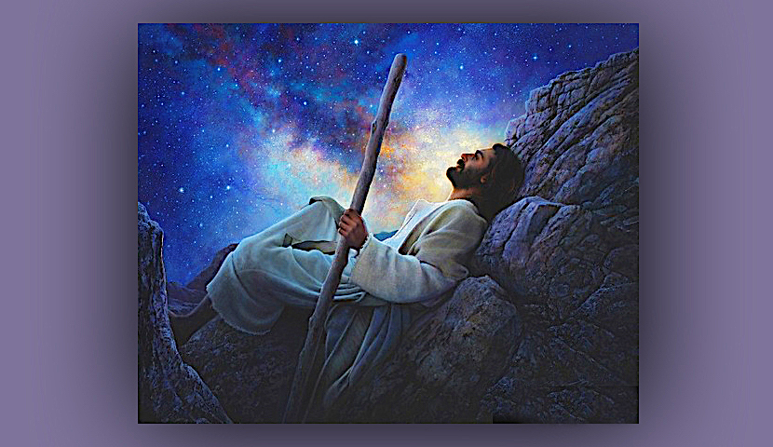
Lord Jesus, Your love is more intense than any one of us can ever understand. Please open our hearts to receive what you long to give us. Amen

Well, dear Heartdwellers, you know how it is... You're getting up from a fall, you kind of distance yourself from the Lord, because you feel badly about yourself. And that's not what He wants. He wants us to run to Him when we get, when we stumble or fall—to run to Him. Run to His arms of forgiveness and love.

But when my attention has been on looking at the dirty diaper that's in MY life, it tends to leave me in a position of feeling convicted, and not really wanting to be around the Lord quite yet, until I fully repent. Which, I suppose, is a good thing, after all.

But, in recovering from all of this, tonight, Ezekiel kept hearing a Michael W. Smith song over and over again, “You Belong to Me.”

The lyrics are so very romantic.

I knew you were the one
My heart was overcome
The day I looked into your eyes

The feeling so surreal
Like time was standing still
When you said you would be mine

Oh, you are a miracle
You're sweeter than I've ever dreamed
You're so much more than beautiful
How can it be that you belong to me?

https://youtu.be/9H4ubwENeeo

Then, as he meditated on that song, he looked it up and He saw Jesus singing that song to me. Ezekiel's been praying really hard for me the last few days, that I could get back in that sweet space with the Lord.

But he saw the Lord singing that song to me. So, he went to the Bible Promises: 'Is this my imagination, Lord—or are You really showing me this?'

And he opened to Holy Spirit, twice in a row! So, he told me. And as I listened to the song, I couldn’t help but cry, that Jesus would feel that way about me—especially after all my recent goof ups.

Still, I had a hard time accepting those lyrics. I felt so unworthy. So, I told the Lord, “Oh, how romantic You are. I guess I just can’t relate to being 'so much more than beautiful.' I just don’t know what to think?”

Jesus replied immediately, “Can you think that I would ever lie to you? Would I flatter you? Is there any such thing as duplicity in My Heart? Would I manipulate you?"

No, but You do lead me with bread crumbs in the dark and mysterious forest sometimes.

"Clare, that’s only because I know how to speak to you, Dearest. I know what gets your attention."

Lord, I don’t want to go back to my vomit. I really don't.

He answered, "Then don’t. You are far beyond that in worth in My eyes. It doesn’t suit you at all, Clare. Really—I mean that. You are way deeper than that. You just resort to those things when you are feeling low and a little lost. When you perceive the spiritual life to be too much for you and you feel like you are failing. Your eyes begin to wander to the familiar, and especially beauty and possessions.

"You have been up some very rough terrain lately, growing a little weary, feeling a little insecure. That’s when you go back to the familiar to grasp at security. But those things are never enough. You think, 'If I could just have this, it is enough.' But later, you find out it is never enough—and something else calls to you. The demons bait you, knowing your likes, dislikes and the way you think.

"Oh, this is such a spiritual battle—and it’s not as obvious as a black panther pulling you down into the water and drowning you. It is far more sinister. I say 'sinister', because it is always done with your destruction in mind. It looks harmless and little, but behind it is a monster bent on destroying your soul and any good you could do for other souls.

"The minute a soul begins to bring change—good change—towards Me, drawing them to Me, the enemy quickly begins assignments against them so they will not reach their full potential. But if their heart is for Me, all it ever does is train them in warfare, so they can train others.

"You look at many Christians as superstars, because they walk in so much faith and are so public. But that is not My standard. Didn’t you wonder about that reading I gave you the other day, about visiting a church that has been doing a great deal of good?"

Now, that was really strange. Because I'd heard some wonderful things about this church and I heard people getting all kinds of blessings and deliverance from it. And when I asked the Lord if we should go there and maybe learn some of the things they were teaching, He gave me 'Money'.

And that's always "Money and the World'. It's not about making money and having money. It's about the world. And when I asked, I was shocked and I thought to myself, 'Oh, that couldn't be what He's talking about. He must be pinpointing something else in my life.

But now that He's bringing it up and He's linking it to that, I'm thinking 'Wow! This doesn't make sense, Lord.'

He continued, "The closest you have ever gotten to what I consider holiness was with St. Francis. That was as pure as it comes. Everything, every form of what others call holiness, degenerates from there."

And St. Francis lived a life almost identical to St. Paul. So that's something that probably would help you relate to what He's saying. Francis came from a wealthy family, and he was completely detached from the class system, and from his family. Because he was head-over-heels in love with the Lord. Nothing mattered to him, then taking care of the poor, the sick and spending hours and days in prayer and worship. He would worship to the point where he would be lifted up above the treetop. And the friars would come looking for him in the forest, and they'd see him above the treetops, conversing with the Lord. And it was beautiful.

And so, I answered the Lord, 'I don’t want to judge or compare, Jesus.'

"Well, I want you to understand. My ways and man’s ways are lightyears apart."

But you honor those people with miracles left and right to attest to their lives.

"Yes, I do, Clare. But I am more concerned with the soul that is totally broken before Me, and this is where you have been going. Truly, it is not about the miracles. Truly it is about humility of heart and hearts that are one with Me.

"And I suffer. Suffering is not taught in Christian circles. You are one of the few who truly addresses it and how important it is to Me. There is SO much missing in the churches today. SO much. Did I not say to those who did miracles in My Name, 'Depart from Me. I never knew you.'"

But it seems to me, Lord, that many in that position have such a heart of gold for people.

"Yes, like Heidi Baker. Indeed, she is one who has lost her life to gain Me. But look how many criticize her in spite of her fruit. They do not know Me; that is why they can't see her.

"I do not want you going around trying to discern who is with Me and who isn’t. That isn’t My point. My point is that so much that is done for show, and it's vain in My eyes. True holiness is hidden and lowly."

Well, Lord, I have not hidden Your gifts to me.

"Because I have asked you to share them. But you have hidden your holiness, in the sense that you speak so much of your lack of qualifications. Not only is that true, but it is a good and healthy as an approach. That is something authentic you learned especially from Francis of Assisi."

Yep, he was sure into that! If he broke a fast, when the brothers were fasting, by eating something that had lard in it or whatever, he would confess it to all of them, so they wouldn't think more of him than what he truly was.

The Lord continued, "Well, what I wanted to say to you is not to envy or exalt those who are in the public eye; and fame does not qualify one to be My friend and Bride. Holiness of life does. It’s not important for you to know who qualifies—that would lead you into sin. Rather, be content with your lowly station and protect it.

"Now, about beauty; true spiritual beauty.

"My Heartdwellers, did I not say blessed are the poor in spirit? In fact, did I not say every Blessed was living contrary to the way the world thinks of blessed? The spiritual life, the true spiritual life is in direct contrast to the world. And so, when you come to belong to Me, it is necessary for you to leave the worldly value system totally behind you.

Even as it is written:

“….don’t you know that all of us who were baptized into Christ Jesus were baptized into his death? We were therefore buried with him through baptism into death in order that, just as Christ was raised from the dead through the glory of the Father, we too may live a new life.” Romans 6:3-4

"When you are baptized into My death, you come up looking so different from the world. That is not to say that only those who look poor are holy. Not at all. It is detachment of heart from personal desires and gain that frees you. Because I have called you to be My Bride, I have also called you to exceptional littleness."

Interesting. The Lord has been giving me rheas when I open my browser. I have it set so that I get a rhema every time I open my browser.

“My child I know your poverty and physical weakness. Allow Me to labor from within you and you shall have all you need.” and “You are the least in the whole house. Always choose the last place. Keep this attitude of heart. Be faithful.”

Now, isn't that interesting. If I've gotten that once, I've gotten that at least 5 times in the last month. Seriously. I mean, that's outrageous. Is my browser stuck on that or what?? But no, it's not, because I'm getting it from different sources.

So, I can’t tell you how many times I’ve truly gotten it: “you are the least in the whole house…” and watching ministers on YouTube, or Sid Roth, has totally convinced me: I am the least in the whole house.

Add that to the Lord chose me for this job, because I was totally unsuitable—and any good that was done He wanted all the credit for. Add that together and that just closes the case.

I know that even with music I can do nothing without His touch.

Lord, when I am in this place, I tend to devalue myself and find it very hard to accept Your love and the tender things You say to me.

Jesus continued, “It is a contradiction, Clare; the littler you are, the more beautiful you are to Me. The less you think of yourself, the more attractive you are to Me. As Mother Theresa once said, 'God likes little things best.'"

I can feel something sick inside of me when I get around opulence. It is not a judgment on the people, but I know the demands this life-style puts on their time and freedom. Lifestyles tend to own people. You choose this job. With it comes obligations and demands—endless demands on your time. Environments that feel sweet to me are little, poor environments. Not squalor, but simple lifestyles that don’t put demands of conformity on all our time.

Jesus continued, "And this is precisely why I want you to keep your life very, very simple. You’ve hit the nail on the head.

Even as it is written, “The sleep of the laboring man is sweet, whether he eat little or much, but the abundance of the rich will not permit him to sleep.” Ecclesiastes 5:12

"Clare, you are beautiful to Me, because your heart is dedicated to Me. The fact that you fall occasionally is only a sign of your humanity, if you get up immediately and keep going. I do not want you to talk down to yourself. I want you to be comfortable with your littleness, and know beyond a shadow of a doubt how precious you are to Me.

"I want you to rest in My words when I sing 'You are so much more than beautiful.

"I want you to receive this truth and not question or doubt Me. Your littleness and dedication to Me, and so much more, has made you more than beautiful. And when I sing “How can this be, that you belong to Me?” I mean it with all My heart.

"Oh, My Brides, when you depart from the world and break away, giving your life unconditionally for Me… I do indeed shed tears of joy and sing, ‘How can this be, that you belong to Me?'”

